BORIS BIZJAK – biography

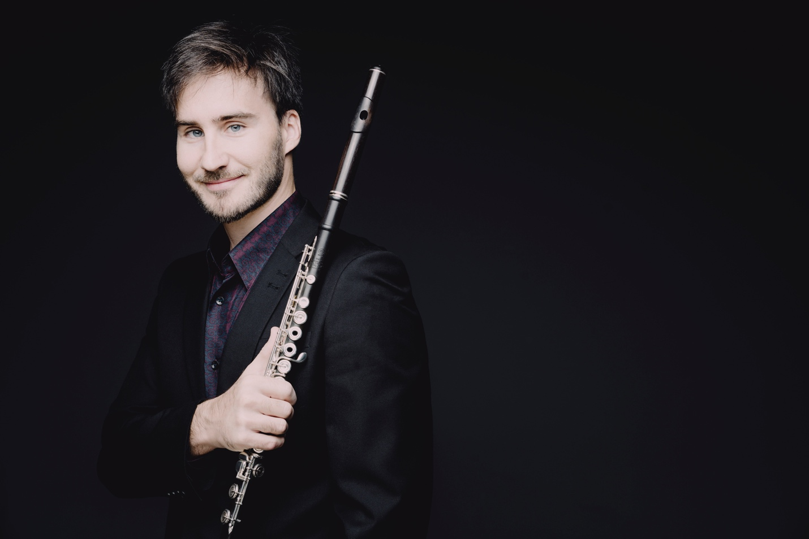

“Freshness and originality” [GRAMOPHONE]
“Bizjak’s playing is of the highest rank” [CLASSICAL EXPLORER]
“Admirable” [BBC MUSIC]
“An exceptional concert, filled with unprecedented musical message” [DNEVNIK]

Slovenian flutist Boris Bizjak, based in London, is the prize-winner of many competitions. He won the 1st and 2nd prize at the European Flute Competition in Picardy, France. He was regularly a top prize winner as a soloist and chamber musician at the Slovenian National competition.

Boris performs as a soloist and chamber musician in Slovenia, Great Britain, the United States, Japan, China, France, Switzerland, Norway, Spain, Cyprus and Malta. He has performed concertos with the Slovenian Philharmonic Chamber Orchestra on a number of occasions; in 2015 he performed Mozart's Concerto for Flute and Harp, in 2017 the CPE Bach flute concerto under the baton of Dmitri Sitkovetsky, in 2018 the Brandenburg Concerto and the triple concerto for flute, violin and harpsichord in a minor by J.S.Bach. He has also performed as a soloist with the City of London Ensemble, Euphonia Symphony Orchestra, Solisti Divini, London Brandenburg Soloists and SNG Maribor. He has performed chamber music with Natalie Clein, Jurij Žislin, Natalija Lomeiko, Fleur Barron, Gareth Lube, Lana Trotovšek, Janis Kelly, Guy Johnston, Simon Lane, Yoko Misumi and Maria Canyigueral in halls such as St. John’s Smith Square and St. Martin in the Fields, Looe Festival, Purbeck International Chamber Music Festival, Festivals at Sea, Totnes Early Music Festival, Brighton Festival and Festival Ljubljana. While touring in Japan, he has performed at the Kyoto Bunka Kaikan Hall, Atsuta Hall in Nagoya and Musicasa Hall in Tokyo. He has also led several master classes in Cyprus, Japan, the UK, Italy and Slovenia.

Bizjak graduated from the Academy of Music in Ljubljana in the class of Fedja Rupel. He also studied in Florence with Marzio Conti, and completed his postgraduate studies in Paris at the Ecole Normale de Musique de Paris Alfred Cortot in the class of Pierre Yves Artaud, and at the École Nationale de Musique de Danse et d'Art Dramatique Marcel Dadi with George Alirol.

Boris is a SOMM recordings artist. His latest CD, including the first recordings of chamber works for flute and strings by F.A. Hoffmeister, was praised in the BBC Music and the Gramophone magazines.

As a baroque flutist, he collaborates with harpsichordist Masumi Yamamoto, with whom he performs in Great Britain, Norway, and Japan. He also performed with the Flaugissimo ensemble and the Oxford Bach Soloists, and at the Ljubljana Festival with gambist Domen Marinčič and harpsichordist Tomaž Sevšek Šramel.

Bizjak is also director of an audio and video production Hedone Records, and the co-founder of the Biennial Chamber Music Festival in Blackheath, UK.

